**LockedMe.in**

Developed by- Ishaan Gautam

[Email-ishaangautam1998@gmail.com](mailto:Email-ishaangautam1998@gmail.com)

**Project Summary**

* Total number of sprints for the project done – 3
  + **SPRINT-1**
    - Code developed for the Main Menu and the second menu without any functions.
  + **SPRINT-2**
    - Code developed for all the functions used i.e. addFile(), deleteFile(), fileLists() and searchFile().
  + **SPRINT-3**
    - Combining the code for all the functions and the menus.
* Core Java concepts used-
  + Collections- to store the names of the files in the directory and to sort them alphabetically.
  + Exception Handling- to keep the program running even if the user enters an invalid input and to keep the flow of application intact.
  + File handling to get the details of all the files in the files directory.
  + Scanner class to take user input.
  + Java functions
* Flowchart-
  + 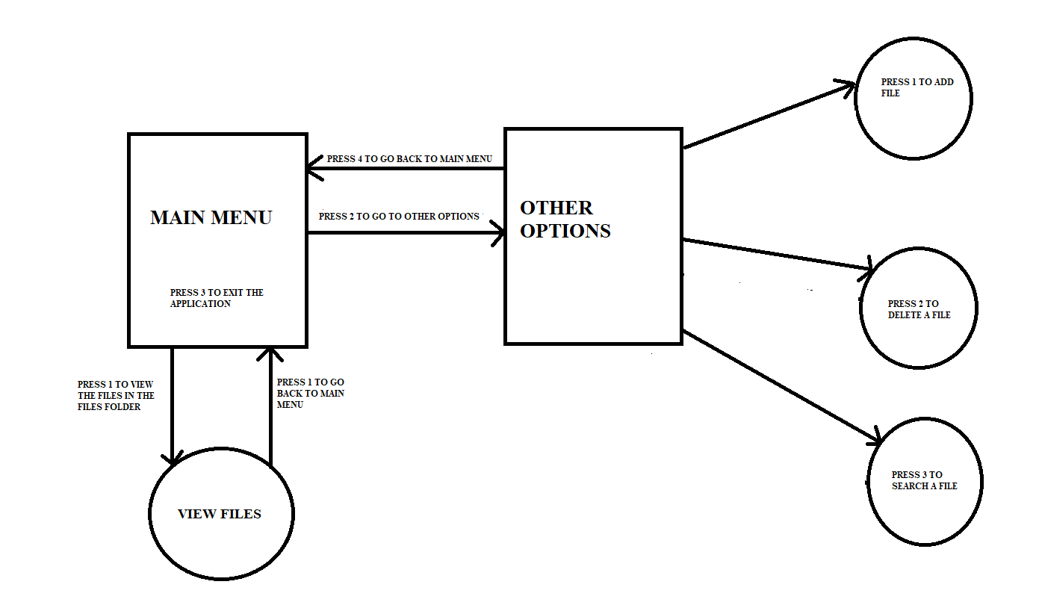
* Screenshots-
  + Main Menu-

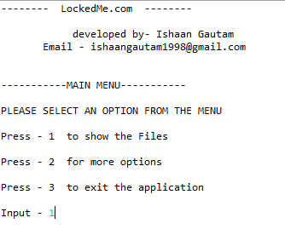

* File list –

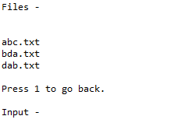

* More Options Menu-

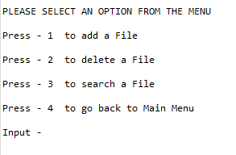

* Github URL- https://github.com/IshaanGautam1/Phase1Project